Future of Four Seasons in Maine and the Maine Data Literacy Project

Can we still be dreaming of a White Christmas?

Background: The scientific consensus is that humans are changing the Earth’s climate. While this has serious implications for human society in the context of security, it also has implications for our way of life. Some Mainers may be wondering if they’re going to be less likely to have white Christmases they remember from their childhood.

The graph below represents snow depth in Portland, Maine on Christmas morning at 7 A.M. for the years 1952 to 2010.
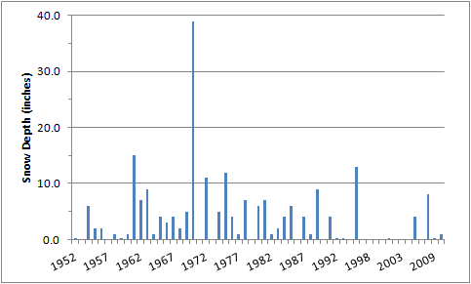
(Data source: http://www.erh.noaa.gov/er/gyx/climate_f6.shtml)

- Describe what the graph shows about how snow depth on December 25th has changed in Portland since 1952. [Purpose here is to elicit description of what the graph shows. Sample response: The graph shows that most Portland Christmases between 1952 and 2010 have from 0 to 15 inches of snow, the only exception being around 1970, when there were nearly 40 inches of snow. In the nine years from about 1998 to 2007 there was only one year with snow on the ground (2003).
- How else might you represent this data set to make the above question easier to answer?
By formatting this data set in a histogram showing the frequency of snowless Christmases by decade (years without bars represent those in which there was no snowfall on Christmas morning), we see that those years appear to become more frequent over time.
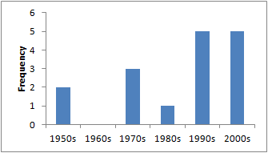
Figure: Histogram of number of snowless Christmas mornings by decade
(Data source: http://www.erh.noaa.gov/er/gyx/climate_f6.shtml)

