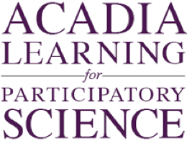
How do the hare and lynx populations relate?
Future of Four Seasons in Maine and the Maine Data Literacy Project

Background: Scientists use models to predict how a system will behave into the future. They will often use real data to validate their models and to see if they actually represent reality.
The graph below shows two relationships through time. One is the relationship of modeled lynx (red line) and hare (blue line) populations to data collected in the field (red dots for lynx data, blue dots for hare data). The other is the relationship between the lynx and hare populations themselves. Because lynx are predators that feed almost exclusively on hare, their population is tied closely to the population of the hares.
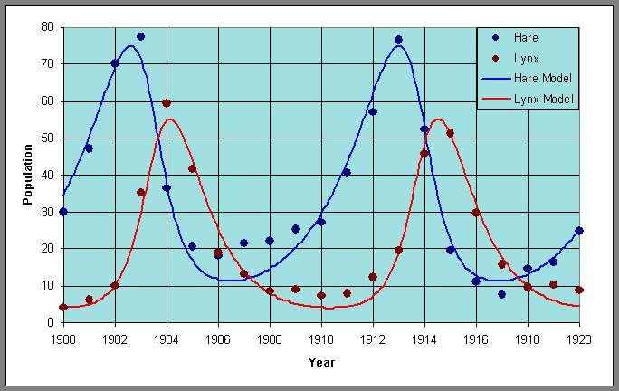
(X1000)
Data Source:
http://www-rohan.sdsu.edu/~jmahaffy/courses/f09/math636/lectures/lotka/qualde2.html

1. Describe what the graph shows about how well the model fits the trends in the data.

2. Describe what the graph shows about how the hare and lynx populations relate to each other.

3. I interpret the graph to mean…. (How do the lynx and hare populations relate?)

