What does the forest look like?
Future of Four Seasons in Maine and the Maine Data Literacy Project

Background: Forests are a big part of Maine’s economy and culture. One important aspect of forestry is understanding how trees grow and what different forests look like at different times after harvest. Sometimes researchers will look at growth rates over time, and other times they will try to characterize what a forest looks like in a single season.
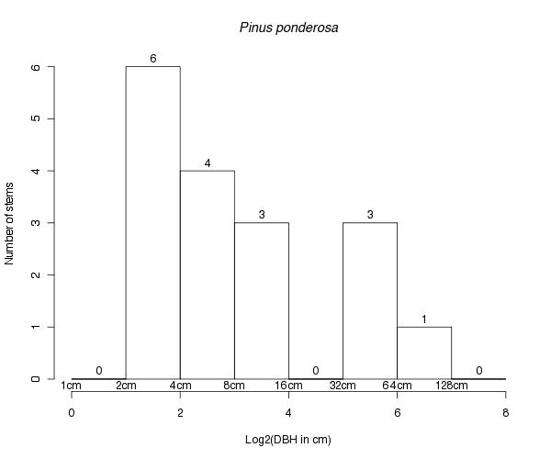
The graph below is a histogram of an experimental plot in a forest in California where the foresters are growing Ponderosa pine. The X axis represents diameters of trees at 1.4m high, and the Y axis represents the number of trees that fall into each category. The graph is designed to characterize the distribution of tree sizes for a given year. Notice the X axis is a Log base 2 scale. That means each bar represents double the diameter of the bar before it (The first tall bar shows trees between 2 cm and 4 cm while the next bar has double the range, 4 cm to 8 cm). This is done because there is a large range of tree diameters and large diameter trees are much less common than small trees.

Data Source: http://ferp.ucsc.edu/plants/inplot/locations/for_species/PINUPO/

1. Describe what the graph shows about what sizes of the Ponderosa pines in this experimental plot.

2. I interpret this graph to mean…

