What can flowers tell us about climate change?
Future of Four Seasons in Maine and the Maine Data Literacy Project

Background: Many naturalists, farmers, and scientists alike enjoy watching the seasons change, and even write down what they see and when they see it. When single observations like these are gathered up over long periods of time, patterns in the data begin to emerge.
The red line in the graph below shows the median first flowering date for 405 plant species throughout England over a 260 year period. The gray area shows the uncertainty in the data. The older data have a wider gray area meaning that the scientists are recognize that the median has a wider range of possible values. This is because the older data might have been collected a bit differently, or maybe it’s harder to interpret some of the older notes from people making observations. The black line shows the mean value for periods of 25 years, and the dotted line shows the most recent 25 years.

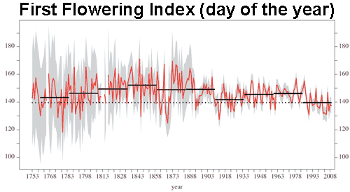
Day of the Year (Number of days since January 1st)
Year

Data Source: Amano, T., Smithers, R. J., Sparks, T. H., & Sutherland, W. J. (2010). A 250-year index of first flowering dates and its response to temperature changes. Proceedings of the Royal Society of London B: Biological Sciences. http://doi.org/10.1098/rspb.2010.0291

1. Describe what the graph shows about how the date that plants in England are flowering has changed over the last 260 years.
Purpose here is to elicit description of what the graph shows. Sample response: This graph shows that the first flowering date of plants in England has varied a lot over the years, but in the last 170 years the dates have been getting earlier overall. Recently, the date of first flowering has been around Day 140, but in the earlier time periods, it was often 4-10 days later.)

2. I interpret the graph to mean….
(Purpose here is to elicit an explanation (e.g. of the pattern or variability) or interpretation of the meaning in terms of the context of the question. Sample response: Flowers in England bloomed earlier on average over the last 25 years than in any of the previous 25 year periods shown. They have been blooming steadily earlier since about 1840, which is one line of evidence of a warming climate in England.)

Teacher’s note: Here is a good article that describes what scientists mean when we talk about uncertainty. It might be useful for sparking a discussion on the topic. http://www.ucsusa.org/global_warming/science_and_impacts/science/certainty-vs-uncertainty.html#.VSaUH_nF-Sp

