What can flowers tell us about climate change?
Future of Four Seasons in Maine and the Maine Data Literacy Project

Background: Many naturalists, farmers, and scientists alike enjoy watching the seasons change, and even write down what they see and when they see it. When single observations like these are gathered up over long periods of time, patterns in the data begin to emerge.
The red line in the graph below shows the median first flowering date for 405 plant species throughout England over a 260 year period. The gray area shows the uncertainty in the data. The older data have a wider gray area meaning that the scientists are recognize that the median has a wider range of possible values. This is because the older data might have been collected a bit differently, or maybe it’s harder to interpret some of the older notes from people making observations. The black line shows the mean value for periods of 25 years, and the dotted line shows the most recent 25 years.

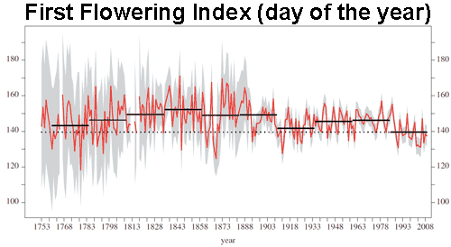
Day of the Year (Number of days since January 1st)
Year

Data Source: Amano, T., Smithers, R. J., Sparks, T. H., & Sutherland, W. J. (2010). A 250-year index of first flowering dates and its response to temperature changes. Proceedings of the Royal Society of London B: Biological Sciences. http://doi.org/10.1098/rspb.2010.0291

1. Describe what the graph shows about how the date that plants in England are flowering has changed over the last 260 years.

2. I interpret the graph to mean….

