Why are rivers in the Colorado River Basin salty?
Future of Four Seasons in Maine and the Maine Data Literacy Project

Background: The Virgin River is a tributary to the Colorado River located in Utah and Arizona. Millions of years ago, the Colorado River Basin was a shallow sea, so the rocks and soils have some naturally occurring salt deposits. When rain and irrigation water filters through the earth, it dissolves some of the salt and carries it to the river. This means that rivers will have different amounts of salt in them depending on where the water is coming from. Snowmelt will have relatively little salt while runoff from rain and groundwater sources will be higher in salt.
The graph below shows the average monthly salt content (salinity) for the Virgin River in each month from 1937-2011. The concentration is in milligrams of salt per liter of river water.
Average Monthly Salinity of the Virgin River (1937-2011)

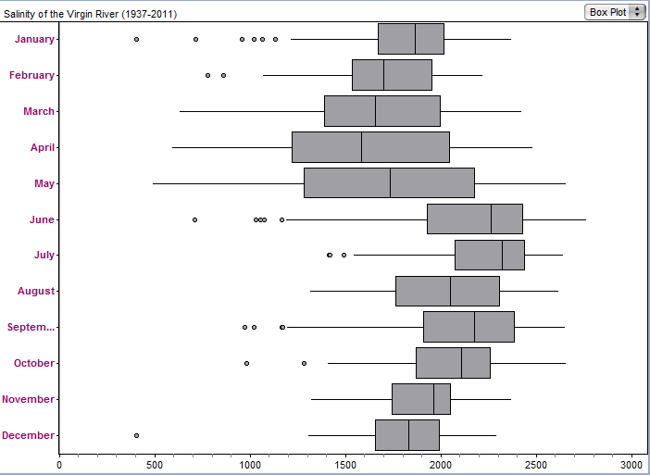
30000
2500
2000
1500

1000

500
0
January
February
March
April
May
June
July
August
September
October
November
December
Salt Concentration (mg/L)

Data Source: http://www.usbr.gov/uc/progact/salinity/

1. Describe what the graph shows about how the salinity of the Virgin River changes throughout the year.
Purpose here is to elicit description of what the graph shows. Sample response: The salinity of the river drops a little in the early spring, then jumps in June and slowly decreases throughout the rest of the year.)

2. I interpret the graph to mean….
(Purpose here is to elicit an explanation (e.g. of the pattern or variability) or interpretation of the meaning in terms of the context of the question. Sample response: When snow is melting from the mountains in the spring, it reduces the salinity of the water.)

