## Marine water and air temperatures: seasonal change

Data Literacy Project

The data for hourly air and surface water temperatures at the West Penobscot Bay buoy between Oct 9 and Oct 16 are displayed in a line graph below.

**Question:** How did air temperature and water temperature at the West Penobscot Bay Buoy change during this fall week?

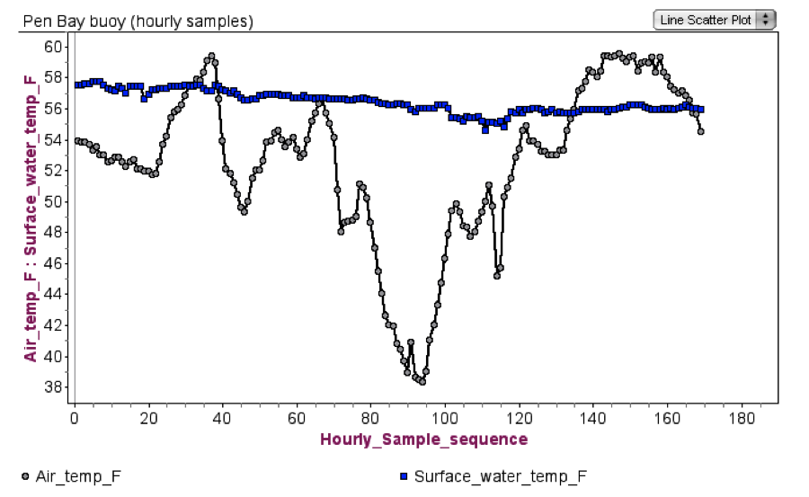

Oct 9, 2012

Oct 16, 2012

[Data are from the Gulf of Maine Buoy system http://www.neracoos.org/datatools/historical/graphing_download]

***Extend your thinking***: How does this line graph help explain the relationship that is evident between air and water temperature shown in the scatter plot (in ML4-PRAC_Pen Bay buoy air-water temps.docx)?

What physical laws do the two graphs (the line graph above and the scatter plot in ML4) show evidence for?