

Data Literacy Project

## When the high tide is extremely high, is the low tide also extremely low?

**Background**: Sometimes the tide is unusually high, as it was this past week when Hurricane Sandy struck the east coast of the United States. When the mean high tide for a given day is extremely high, is the mean low tide for that day extremely low? In other words, is the *height* of mean high tide on a given day correlated with the height of mean low tide for that day?

**Question**: *Are the mean heights of high and low tides on any given day correlated?*

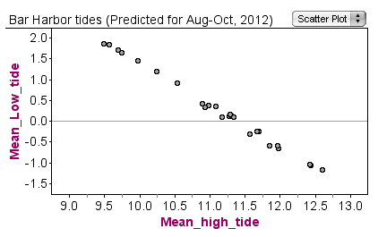

1. Why is a scatter plot a good choice to show evidence to answer this question? (Use the Graph Choice Chart to explain your reasoning).
2. Write a caption for the graph stating a claim that answers the question, *Are the mean heights of high and low tides on any given day correlated?*