

Data Literacy Project

## Are morning tides higher than afternoon tides?

**Background**: As tide tables indicate, there are approximately two high tides and two low tides each day (24-hour period). Because the tide cycle is a little more than 12 hours, occasionally a tide occurs just after midnight, so it is recorded for the next day, but on most days there is a morning high tide and an afternoon or evening high tide.

**Question**: *During August, September, and October of 2012, did high tides tend to be higher in the morning (a.m.) than in the afternoon (p.m.)?*

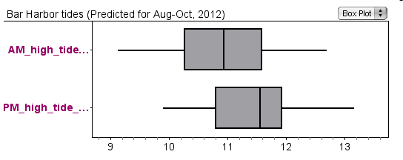

1. Why is a box plot a good choice to show evidence to answer this question? (Use the Graph Choice Chart to explain your reasoning).
2. Write a caption for the graph stating a claim that answers the question, *During August, September, and October of 2012, did high tides tend to be higher in the morning (a.m.) than in the afternoon (p.m.)?*

3. **Extended thinking**: Why might morning and afternoon tides be different? (Consider the relative positions of the Sun, Moon, and Earth at the times of high tide during these three months). Do you think this difference would be the same throughout the year?