Data Literacy Project

Carbon dioxide sources

Carbon dioxide (CO₂) is a major air pollutant that is contributing to a rise in global temperatures. It is a waste product of burning carbon-based fuels such as oil, gas, coal, and even wood. Electric generating plants release large amounts of CO₂ each year as they burn coal or oil to generate electricity. Cars and trucks also emit CO₂ out the tailpipe when they burn gasoline.

The US EPA is working to create rules that will reduce the amount of CO₂ released to the atmosphere. The table below shows how much CO₂ (in millions of metric tons) has been released each year by the electric power industry and by vehicle traffic in the US.

Year | Electric Power Industry (millions of metric tons of CO₂ produced) | Transportation (millions of metric tons of CO₂ produced)
2005 | 2,450 | 2,020
2006 | 2,400 | 1,990
2007 | 2,460 | 2,000
2008 | 2,410 | 1,900
2009 | 2,200 | 1,820
2010 | 2,310 | 1,830

US Greenhouse gas emissions by sector, in millions of metric tons of carbon dioxide.
Source: Adapted from table ES-7, http://www.epa.gov/climatechange/ghgemissions/usinventoryreport/archive.html

1. Make a graph that compares how much CO₂ the two sources – the electric power industry and transportation (vehicle traffic) – produce each year.

2. Describe what your graph shows about how electrical generation and transportation compare in annual CO₂ production.

Teaching notes

Chemistry
Env. Science
Compare groups

While this is set up as a “compare groups” question, students might also answer the question as a time series because the data are given for a sequence of consecutive years.
A comparison can also be described between two time series – either approach would be acceptable.

Here are box plots, dot plots, and a line graph for the data set. The important thing is that however the students chose to graph the data, (1) the data are plotted accurately and (2) their explanation is supported by (is consistent with) the graph they drew.
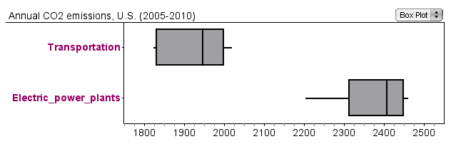
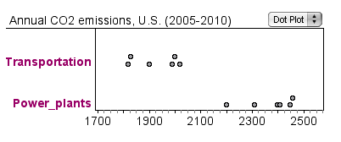
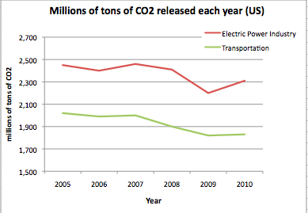

For extended discussion:

- Which sector (source) of carbon dioxide would it make the most sense for the EPA to regulate first?

- How is each sector changing through time?

- How has each sector been changing since 2010? (Requires retrieving more current data).

