**How high is high tide?**

Data Literacy Project

**Background**: Anyone who has spent more than a few hours by the Maine’s coastal shore line knows that the height of the water changes noticeably over the course of several hours due to the coming and going of the tide. In fact, some of the highest tides in the world occur in Maine and in the neighboring Bay of Fundy.

The height of the tide is measured by how far it rises vertically from mean low tide (or *m.l.w.*) – not by how far it rises up the sloping shore. The tide comes and goes twice a day, so there are two high tides and two low tides approximately every 24 hours. There are about 12 hours and 24 minutes between each high tide.

**Question**: *Do all high tides in Bar Harbor rise to the same height*?

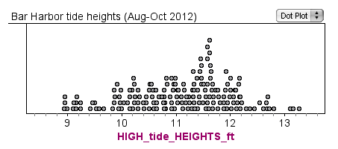The frequency plot below shows the predicted heights (in feet) of all of the high tides in Bar Harbor, Maine, between August 1 and October 12, 2012. The x-axis is the scale for height (in feet) above mean low tide (m.l.w.). Each dot represents a different high tide. (The dot plot doesn't show *when* any of the high tides occurred, it only plots all of the high tides as a group, sorted by height above m.l.w.).

1. Which of the following best describes the question *Do all high tides in Bar Harbor rise to the same height*?
2. It asks about how much a measurement varies within a group
3. It asks about how two groups compare in a single measurement
4. It asks about the correlation between two variables
5. It asks about how something changes through time
6. None of the above describes my question very well

2. What does each dot in the above graph represent?

3. Based on the evidence in the graph, how would you answer the question *Do all high tides in Bar Harbor rise to the same height*?