**What can be learned from a tide table?**

Data Literacy Project

**Background**:

In Maine it is useful to be able to predict the timing and the height of the tide because here there is such a big difference in height between high and low tides. The vertical difference can be more than ten feet! The National Oceanographic and Atmospheric Administration (NOAA), the US Navy and many other organizations publish tide tables for many coastal locations in North America and around the world so that fishermen, sailors and anyone spending time on the salt water or at the shore can know when the tide will be high, when it will be low and how high or low the tide on any given day will be.

Examine the tide table below. It gives the timing and the heights of high and low tides in Bar Harbor, Maine, for the months of August, September and October 2012. Think about what the data in the table say about tides. Write two questions about tides that could be answered using the data in the table as evidence.

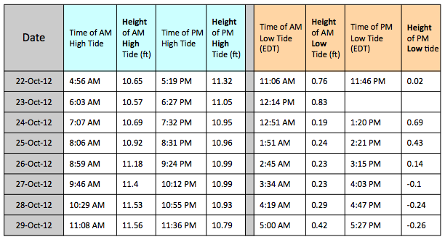

1. Which of the following best describes each of the questions you wrote?
2. My question asks about how much a measurement varies within a group
3. My question asks about how two groups compare in a single measurement
4. My question asks about the correlation between two variables
5. My question asks about how something changes through time
6. None of the above describes my question very well

2. What kind of graph would be the best to use to answer each of your questions?